Markov Text Generator
Nruta Choudhari, 2024

Below is the screenshot of the output of test_example.csv:
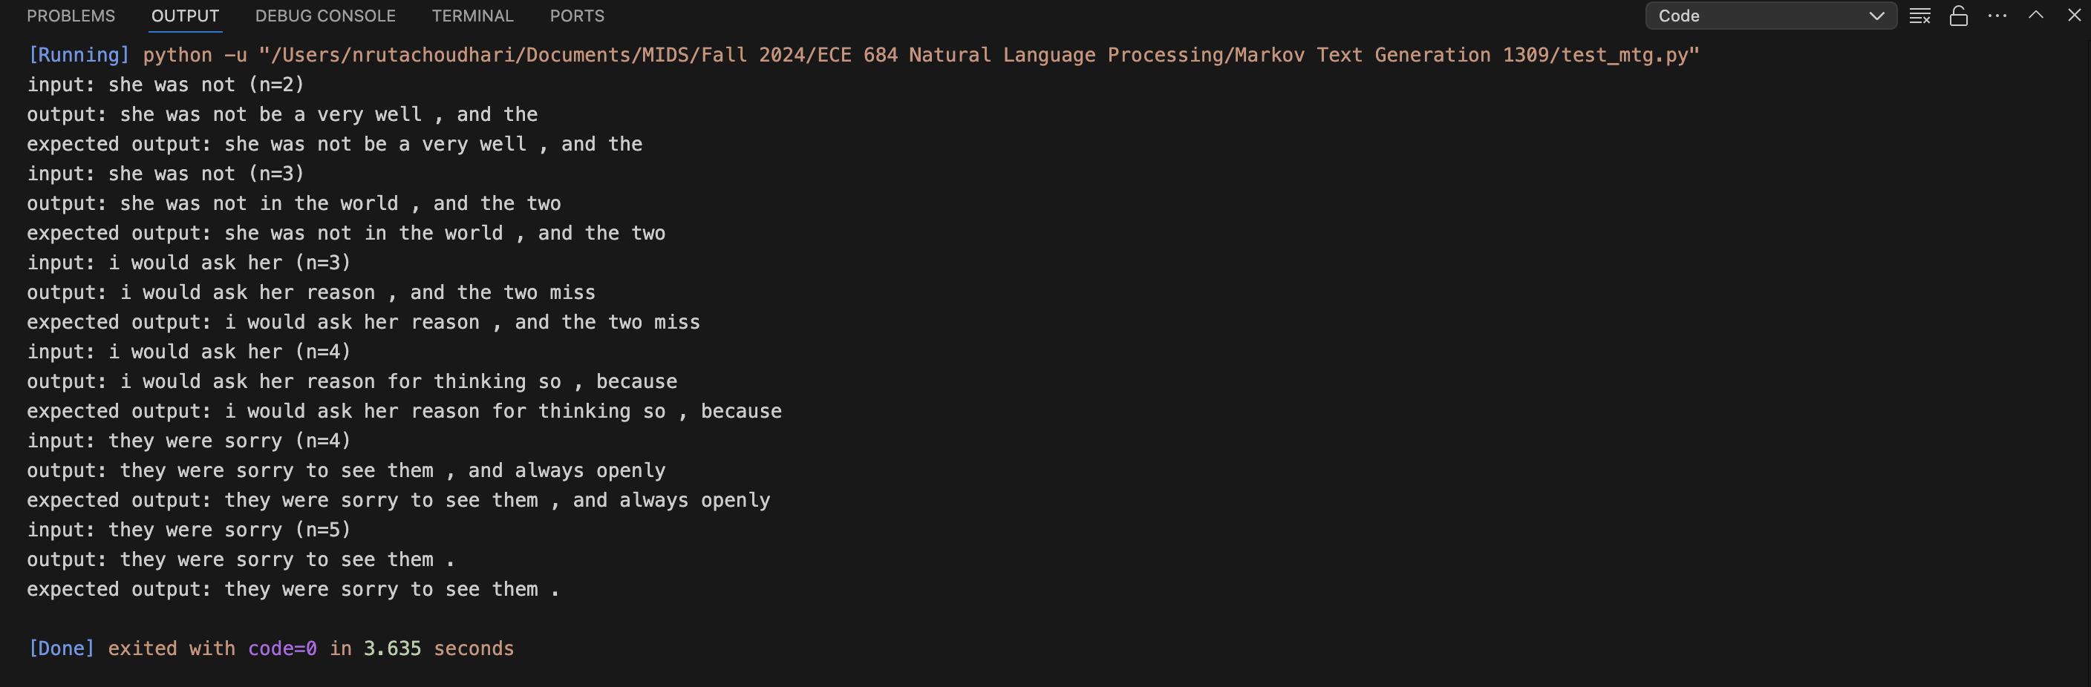

Below are some more examples to show for randomized and deterministic models.
- n =2
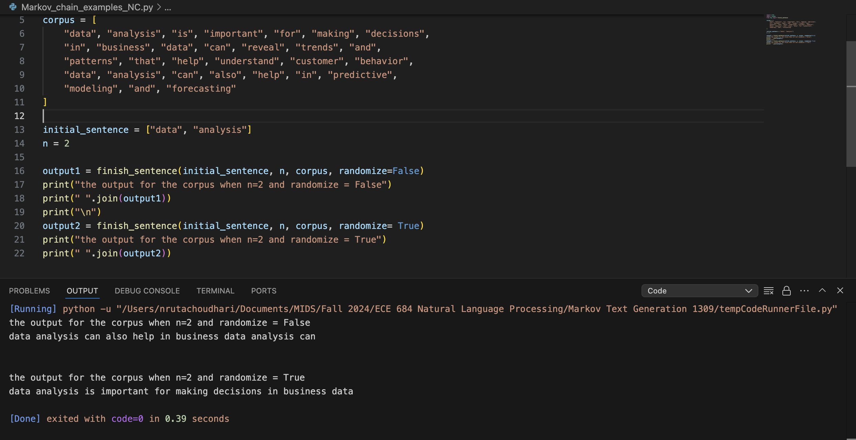

- n = 3

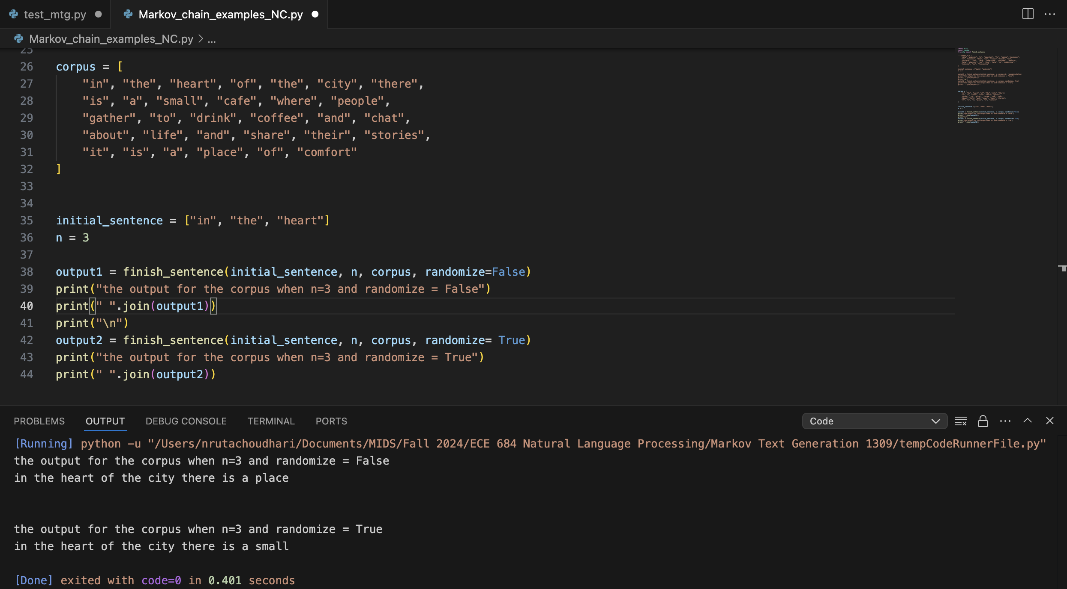

- n =4
